SPI Serial Programming
Algorithm

When writing serial data to the ATmega16, data is clocked on the rising edge of SCK.
When reading data from the ATmega16, data is clocked on the falling edge of SCK. See
Figure 138 for timing details.
To program and verify the ATmega16 in the SPI Serial Programming mode, the following
sequence is recommended (See four byte instruction formats in Figure 116 on page
276):

1. Power-up sequence:
Apply power between VCC and GND while RESET and SCK are set to “0”. In
some systems, the programmer can not guarantee that SCK is held low during
power-up. In this case, RESET must be given a positive pulse of at least two
CPU clock cycles duration after SCK has been set to “0”.

2. Wait for at least 20 ms and enable SPI Serial Programming by sending the Programming
Enable serial instruction to pin MOSI.

3. The SPI Serial Programming instructions will not work if the communication is
out of synchronization. When in sync. the second byte ($53), will echo back
when issuing the third byte of the Programming Enable instruction. Whether the
echo is correct or not, all four bytes of the instruction must be transmitted. If the
$53 did not echo back, give RESET a positive pulse and issue a new Programming
Enable command.

4. The Flash is programmed one page at a time. The page size is found in Table 107
on page 262. The memory page is loaded one byte at a time by supplying the 6
LSB of the address and data together with the Load Program Memory Page
instruction. To ensure correct loading of the page, the data Low byte must be
loaded before data High byte is applied for a given address. The Program Memory
Page is stored by loading the Write Program Memory Page instruction with
the 7 MSB of the address. If polling is not used, the user must wait at least
tWD_FLASH before issuing the next page. (See Table 115). Accessing the SPI
Serial Programming interface before the Flash write operation completes can
result in incorrect programming.

5. The EEPROM array is programmed one byte at a time by supplying the address
and data together with the appropriate Write instruction. An EEPROM memory
location is first automatically erased before new data is written. If polling is not
used, the user must wait at least tWD_EEPROM before issuing the next byte. (See
Table 115). In a chip erased device, no $FFs in the data file(s) need to be
programmed.

6. Any memory location can be verified by using the Read instruction which returns
the content at the selected address at serial output MISO.

7. At the end of the programming session, RESET can be set high to commence
normal operation.

8. Power-off sequence (if needed):
Set RESET to “1”.
Turn VCC power off.

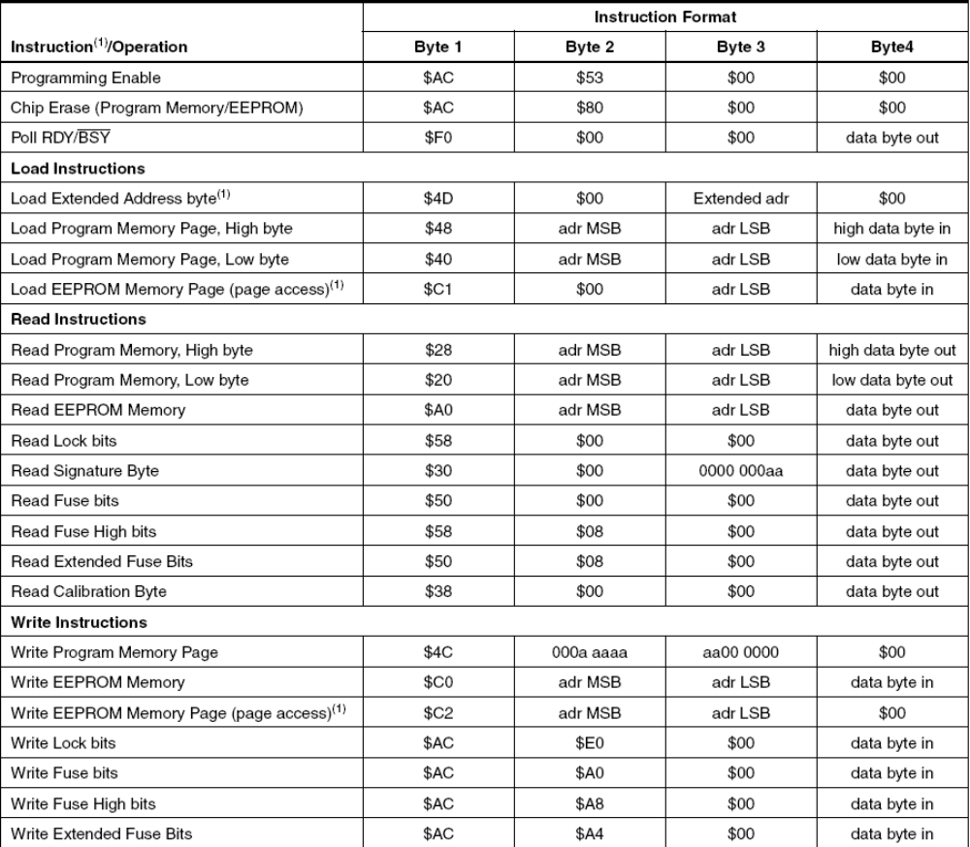

{Wait for at least 20 ms and enable SPI Serial Programming by sending the Programming
Enable serial instruction to pin MOSI.
The SPI Serial Programming instructions will not work if the communication is
out of synchronization. When in sync. the second byte ($53), will echo back
when issuing the third byte of the Programming Enable instruction. Whether the
echo is correct or not, all four bytes of the instruction must be transmitted. If the
$53 did not echo back, give RESET a positive pulse and issue a new Programming
Enable command.}

{Power-up sequence:
Apply power between VCC and GND while RESET and SCK are set to “0”. In
some systems, the programmer can not guarantee that SCK is held low during
power-up. In this case, RESET must be given a positive pulse of at least two
CPU clock cycles duration after SCK has been set to “0”.}
{
* Reset the microcontroller by setting RESET LOW.
* Set SCLK LOW (done by software).
* Give RESET a positive pulse of at least two system clock cycles duration (needs to be done manually).
* Tell the software to set the device into programming mode.
}
procedure power_up() ;
var
i:integer;
begin
form1.ComPort.SetRTS(true);
sleep(30);

form1.ComPort.SetDTR(true);
sleep(30);
form1.ComPort.SetRTS(true);
for i:=0 to 1000 do ;
form1.ComPort.SetRTS(false);
for i:=0 to 1000 do ;
form1.ComPort.SetRTS(true);
for i:=0 to 1000 do ;
end ;

function programming_enable: Integer;
var data,tryme,i:integer ; str:string;
begin
form1.ComPort.WriteStr(inttostr($ac));
for i:=0 to 1000 do ;
form1.ComPort.WriteStr(inttostr($53));
for i:=0 to 1000 do ;
form1.ComPort.WriteStr(inttostr(0));
for i:=0 to 1000 do ;
form1.ComPort.Read(Data,Form1.ComPort.InputCount);//data = exchange(aspp,0x00);
for i:=0 to 1000 do ;
form1.ComPort.WriteStr(inttostr(0));
for i:=0 to 1000 do ;
tryme:=0;
inc(tryme);
while ((data<>$53) and (tryme<40)) do//40
begin
power_up() ;

form1.ComPort.WriteStr(inttostr($ac));
for i:=0 to 1000 do ;
form1.ComPort.writestr(inttostr($53));
for i:=0 to 1000 do ;
form1.ComPort.Read(Data,Form1.ComPort.InputCount);//data = exchange(aspp,0x00);
for i:=0 to 1000 do ;
form1.ComPort.WriteStr(inttostr(0));
for i:=0 to 1000 do ;
form1.ComPort.WriteStr(inttostr(0));
for i:=0 to 1000 do ;
inc(tryme);
end
//programming_enable:= 0x53;
end;

procedure write_program_memory(sb,address,data:integer) ;
var i:integer;
begin
with form1.comport do
begin
if sb=1 then
begin
WriteStr(inttostr($48)) ;
for i:=0 to 1000 do ;
end
else
begin
WriteStr(inttostr($40));
for i:=0 to 1000 do ;
end;
writestr(inttostr((address shr 8) and $ff));
for i:=0 to 1000 do ;
writestr(inttostr(address and $ff));
for i:=0 to 1000 do ;
writestr( inttostr(data and $ff));
for i:=0 to 1000 do ;
sleep(5); // wait at least 4ms to read/write next byte
end;
end;

procedure power_off() ;
var i:integer;
begin
form1.ComPort.SetDTR(false);
for i:=0 to 1000 do ;
sleep(30);
form1.ComPort.SetRTS(false);
for i:=0 to 1000 do ;
sleep(30); // wait >20ms
end ;

